What We are Getting Wrong When We Measure Campaign Spending
Steven Sprick Schuster: Middle Tennessee State University
Researchers of elections have long understood the importance of obtaining unbiased estimates of the effect of candidate spending on electoral outcomes, which has led to a vast body of literature beginning, in the modern period, with the work of Jacobson (1978, 1980, 1990), and proliferating ever since (Strattman (2005) provides a thorough review). Given the strict filing and disclosure rules for campaigns, researchers have been confident that they were measuring candidate disbursements with precision, leading Levitt to state that “measurement error is unlikely to be a major concern here. Federal law requires disclosure and detailed accounting of every campaign expenditure over $200.” (Levitt, 1994, p. 787).

While the literature has relied on an accurate measure on the total disbursement of candidates, it has largely ignored how campaigns spent money. For many years, this was out of necessity, as the best measure of candidate spending was aggregate measures of candidate disbursement. These measures may not have been perfect, but their use is certainly understandable, given the dearth of any feasible alternatives. Unfortunately, this means that much of the research on candidate spending has treated the measurements of campaign activity themselves like a black box.

While relying on a precise, if poorly defined measure of campaign activity, a massive literature has created numerous debates about the effect of campaign spending. Why does spending not appear to be more effective, given the importance political parties place on fundraising? Why does incumbent spending appear to be less effective than challenger spending? These debates are fueled by the wide range of causal estimates found in the literature, with some studies finding large, robust effect (Erickson and Palfrey, 2000), while others find little effect at all (Levitt, 1994).

Recent literature on the effect of campaigning on electoral outcomes has wisely begun to focus on precisely measured components of campaign activities such as advertising or voter contact (Strattman, 2009; Kella and Broockman, 2020; Sides et. al., 2021). Nonetheless, ideas of the effect of campaign spending continue to be shaped by research that uses candidate disbursements as the primary independent variable, and campaign spending is a crucial measurement of how money can influence election outcomes.

When papers use vote share or the probability of victory as the outcome variable, the relationship between the chosen spending variable and the outcome variable depends on the degree to which candidates are actually using money to affect those outcomes. If a researcher finds that spending has no effect, is it because candidates are trying (and failing) to change voter behavior through their spending, or is it because they are not using spending to try to change voter behavior?

Candidate disbursements includes both campaign operating expenditures as well as other payments, such as loan repayments, contributions, and other transfers out of campaigns. As such, disbursements fail to accurately measure meaningful campaign activity, and by using them as their independent variable, researchers are including millions of dollars in payments that are not being used on a candidate’s own campaign.

This point was previously made by Ansolabehere & Gerber (1994), who used digitized disbursement-level data for the 1990 midterm elections. They found that using more precise measures of candidate spending makes the coefficients on incumbent spending on incumbent vote share in an OLS regression negative, which shows that a better measure of spending does not address the underlying biases of OLS regressions. Ansolabehere & Gerber were trying to answer whether or not the “mismeasure” of candidate spending is what was leading to seemingly ineffective incumbent spending, but because they were not also addressing the omitted variable bias of OLS regressions, they were limited to showing how the association between spending and vote shares changed. Sprick Schuster (2020) build on this insight by showing how the estimates of marginal effect in a quasi-experimental setting changed when more precise definitions of candidate spending are used.

By disaggregating candidate disbursement data, this paper expands the findings of both by Ansolabehere & Gerber (1994) and Sprick Schuster (2020) by showing how the standard measures of candidate spending are a likely cause of some of the most confounding results found in the literature of the effect of campaign spending. First, only a portion of candidate spending is being used on a candidate’s own campaign, including significant portions of the marginal dollars being spent. Second, while disbursements remain high as vote shares approach 100 percent, spending on activities associated with reaching voters, such as advertising, becomes a tiny fraction of overall spending, while fundraising and party contributions increase. Finally, aggregate measures of candidate disbursements overstate the amount of incumbent spending by significantly more than challenger spending, and I show that incumbency status causes campaigns to change their pattern of spending, away from electoral useful spending (such as advertising), meaning that even if a paper successfully controls for unobserved candidate quality, comparisons of challenger and incumbent spending are comparing compositionally different bundles of spending.

These results suggest that the common finding of ineffective incumbent spending (and relatively ineffective spending by candidates as a whole) is influenced by the way spending is measured. By using candidate disbursements as a proxy for useful campaign spending, researchers are including hundreds of millions of dollars of spending are transferred out of a campaign entirely. These issues plague Senate campaigns less than House campaigns, likely due to the competitive nature of Senate campaigns.

Data
I use the whole universe of candidate disbursements reported to the FEC for 2004-2018. This includes every individual disbursement of each campaign. This allows me to measure both Total Disbursements, which has long been the standard measure of campaign activity, as well as the following categories: operating expenditures, transfers to other committees, refunds, loan repayments, donations and contributions. I also use transaction-level data on operating expenditures to determine the kind of spending in which campaigns are engaged.

Disbursements, Operating Expenditures, and “Useless” spending

According to the FEC, ‘“Disbursement" is a broader term that covers both expenditures and other kinds of payments (those not made to influence a federal election).” These “other kinds of payments” are loan repayments, transfers to other committees, refunds, and contributions. Throughout this paper, I call these “useless” disbursements, because these disbursements are useless in changing the outcomes typically measured in the literature: vote shares and probability of winning elections.

Figure 1, Panel A shows the disbursements for all candidates in the U.S. House and Senate alongside useless spending. These disbursements represent at least 32.1% of all disbursements in U.S. House campaigns and 18.2% in U.S. Senate elections. Panel B compares the spending patterns of incumbents to non-incumbents. Incumbents spend a much larger percentage of their disbursements in sending money directly out of their campaign. The average incumbent for a U.S. House had $1.65 Million in disbursements, but almost 45% of those disbursements were transfers, refunds, donations and loan repayments. Non-incumbents have about $750,000 in disbursements, but only 18% of that is useless. About 24% of Senate incumbent disbursements are useless, compared to 13% by other candidates. By using disbursement data, researchers are over-stating the amount of money spent on elections, but they are overstating the amount incumbents spend by more.

Many members of Congress, especially safe incumbents, are expected to “pay into the party” by giving to the party or other candidates. To use one of many possible examples, consider Nancy Pelosi’s 2008 campaign. According to the FEC, Pelosi’s campaign spent $2.7 million in disbursements, despite facing no serious competition and winning her re-election by 55 points.

Unsurprisingly, only small portion ($880,000) of that $2.7 million was spent on operating expenditures, and a large portion of that $880,000 was fundraising. Most of the remaining disbursements were contributions, $1.355 million of which came from 15 separate contributions to the Democratic Congressional Campaign Committee. While much of this $1.355 million may have gone to increasing the vote shares of Democrats, it did not increase the vote shares of Pelosi.

While misclassifying some disbursements as campaign spending leads to an overestimate of campaign activity, it would not necessarily alter estimates of marginal effect. If these non-campaign disbursements represent fixed costs for campaigns, they would not increase with total disbursements, and estimates of marginal effect would be similar regardless of whether these costs included. It is even possible that growth in actual campaign activity is greater than growth in disbursements, if campaigns spend less on transfers, contributions, donations, and refunds as disbursements grow. What happens to these categories of spending when disbursements increase?

Figure 2 shows that for both House and Senate general election candidates, researchers are also misclassifying marginal spending when they use total disbursements. When disbursements increase, campaigns increase useless spending. Using a simple quadratic regression, I predict that when the median House campaign increases disbursements by $100,000, it increases useless spending by $24,935. This number is $15,842 for the median Senate campaign.

It is simple to see how including useless spending in the independent variable of interest changes estimates of causal effect. Suppose that a researcher finds that a $100,000 increase in House candidate disbursements leads to 1 percent increase in vote shares. Because all this marginal effect will be caused by the $75,065 increase in operative expenditures, it can cause the researcher to implicitly underestimate the value of actual campaign spending. True, a $100,000 increase in candidate disbursements could lead to a 1 percent increase in vote shares, but a $100,000 increase in operating expenditures would lead to a 1.33 percent increase ($100,000/$75,065) in a candidate’s vote share. This is more than just a semantic argument, given that so much of the research has used disbursements and campaign spending as interchangeable concepts. They are not. One is an accounting definition used by the FEC, the other is the cost of actual, observable campaign activity. Even when researchers obtain unbiased estimates of the effect of candidate disbursements, they are likely not finding unbiased estimates of candidate spending.

The marginal dollar spent by incumbents is far more likely to include useless spending that the marginal dollar spent by challengers. A $100,000 increase in disbursements increases useless spending for incumbents by about $30,840, but only $13,930 for challengers. For the Senate, these numbers are $10,056 for incumbents and $5,423 for challengers. The puzzle of ineffective incumbent spending is really no puzzle at all. Instead of asking why the effect of challenger disbursements are smaller, we should ask why, if 45 cents of every dollar of incumbent disbursement (and 31 cents of the marginal dollar) is sent directly out of the campaign, would we expect incumbent disbursements to be as “effective” as challenger disbursements in increasing vote share?

Just as candidate disbursements overstates candidate spending for incumbents more than challenger, it overstates the spending of politically safe candidates more than it does candidates in competitive elections. Researchers have long noted that candidate disbursements increase as elections get more competitive, identifying this “reactive spending” as one of the main sources of omitted variable bias. But as elections get more competitive, campaigns also change the composition of their spending.

Figure 3 shows how various measures of campaign activity vary across election competitiveness. Both total disbursements and operating expenditures increase significantly when races become more competitive, though disbursements increase by more. Surprisingly, the amount of money campaigns send out in the form of contributions increases as races become more competitive, especially in House elections. Since competitive elections tend to be high profile ones, this suggests that parties use competitive elections as fundraising opportunities, allowing them to raise funds for other elections.

When candidates face little competition, they do not stop all their spending, but they do change how they spend. As races become less competitive, election winners spend less on advertising and more on fundraising. In House elections, when races were competitive, candidates spent more than 40% of their operating expenditures on ads and less than 20% on fundraising. In races that were not competitive, the winners (those who received more than 80% of the vote share) spent almost three times as much on fundraising as they did on ads. For Senate elections, spending patterns do not vary nearly as much, largely because there are few non-competitive Senate races.

This reinforces the lessons learned from Erickson and Palfrey (2000), who found that the effect of candidate spending was greater when races are expected to be close. Interestingly, they present their framework as a way of addressing the endogeneity problem of campaign spending. My analysis shows that the differences between the effects of marginal spending in close races and uncompetitive ones may also be attributable to the differences in spending patterns. Candidates in non-competitive races will spend more money engaging in fund-raising and contributions. In close elections, more money in spent on ads. It follows naturally that the marginal effects of those expenditures will also differ, as long as ads are a more effective way of increasing vote shares than contributions to other candidates.

Incumbent Spending Patterns: Causality or Selection?

Given that the average incumbent uses their disbursements in a different way than challengers, an interesting question (especially for researchers) is whether these differences in spending patterns are caused by incumbency status, or simply the by-product of selection. After all, incumbents are more likely than challengers to be high-quality candidates. If an existing paper using aggregate candidate disbursements fully controlled for candidate quality (Jacobson, 1990; Green & Krasno, 1988), could a true apples-to-apples comparison of the effect of candidate spending be possible?

Using two separate comparisons, I show that it is not, especially for House candidates. First, Figure 4 compares the spending by the same candidates when they were challengers and incumbents. Therefore, the differences between the incumbents and challengers is due to changes in the behavior of the same candidates. Becoming an incumbent is associated with a 28 percentage point decrease in the share of disbursements used as a campaign’s operating expenditures. For Senate candidates, it’s a 24 point drop. Regression results show a statistically significant difference between the behavior of the same candidate when they are a challenger and when they are an incumbent.

Using a regression discontinuity design, I can see how becoming an incumbent decreases the share of candidate disbursements used on their own campaign. Figure 5 shows operating expenditures as a percentage of candidate disbursements for a party in an election cycle. The X-axis show’s that party’s vote share in the previous election relative to the winning candidate (in elections lost) and the 2nd place candidate (in elections won). The discontinuity at 0 represents the change from barely losing to barely winning an election. When a party narrowly wins an election, the share of disbursements used on that candidate’s operating expenditures drops significantly, which means that being the incumbent party causes a shift in spending patterns away from electorally useful spending towards contributions to other candidates. Regression results suggest that this jump is about 15 percentage points, and the different for Senate elections is statistically insignificant.

This set of results show that incumbency status causes a change in spending patterns towards disbursements outside a candidates own campaign, which means that the differences in spending patterns observed across challengers and incumbents in House elections will survive researchers’ attempts to rid their specifications of omitted variable bias, such as unobserved candidate quality. Even if researchers can control for candidate quality, or any number of other potential confounding variables, they will be comparing sets of challenger and incumbent disbursements that are very different compositions.

This effect is consistent with candidates using the cushion provided by their incumbency effect to re-direct money out of their campaign. Because incumbency increases the chances of winning elections, utility-maximizing candidates will likely devote more resources to raising money for the party. In fact, it is hard to imagine that the incumbency boost would have no equilibrium effect of how campaigns allocate their resources.

The policy relevance of these findings is in how they change the way we should think about how candidates can influence their own elections. Numerous studies (Levitt, 1994; Bonneau and Cann, 2011) that have found incumbent spending to be less effective than challenger spending have claimed that their results suggest that limits of campaign spending would hurt challengers more than incumbents. But those conclusions can not be drawn simply from the finding that the marginal dollar spent by incumbents is less impactful that the marginal dollar for challengers. Incumbents are more likely to be electorally secure and therefore spend more money fundraising and contributing to other races. That these disbursements are not effective at increasing their own vote share does not mean that incumbents cannot effectively use spending, when they choose to, to win elections.

Conclusion

In contributing to the candidate-spending policy debate, one of the most important questions for empirical research to answer is: how much are candidates able to use electioneering to influence the outcome of elections? Instead, we have typically focused on answering a different question: what is the marginal effect of a dollar spent on election outcomes? In a world in which every dollar spent by a candidate goes towards increasing their vote share, these are equivalent questions. But we don’t live in that world.

Instead, we live in a world where candidates spend a large portion of their disbursements on other candidates campaigns. Or in repaying loans that were taken out earlier in the campaign. Or refunding campaign contributions. When researchers use disbursements to measure candidate spending, they are overestimating the amount of money a candidate spends on their own campaign. Since marginal spending also includes these forms of “useless” spending, the resulting estimates of the effect of candidate spending are smaller than they would be if candidate spending were measured using only disbursements that were aimed at changing the minds or behavior of potential voters.

My analysis understates the extent to which researchers overestimate the level of meaningful campaign activity. Since fundraising expenses (and the associated staff, travel, and event costs) are used to raise funds that will be donated, millions of dollars in operating expenditures are being used for reasons other than improving a candidate’s vote share. Though determining exactly which expenditures fall into this category is not possible with total accuracy, fundraising numbers give us some clue. Fundraising constitutes more than 13% of House incumbent disbursements, but only 5% of House challenger disbursements.

It is telling that I find that in competitive elections, and in Senate elections as a whole, I find that candidates spend a higher percentage of their disbursements on their own campaign. Studies that have focused on these elections (Erikson and Palfrey 2000, Abramowitz 1988, Gerber 1998) find candidate spending, and incumbent spending particularly, to be relatively more impactful. These results show that, when incumbents have a higher need to increase their vote share, the effect of the marginal dollar spent increases.

So what can researchers do? Given the imprecision of candidate spending aggregates in defining true candidate spending, an aggregate measure of candidate disbursements is worse than a course measure: it is a systematically misleading one. Researchers may be better served by using disbursement-level data to isolate spending that they can be confident are actually being used for a specific campaign purpose. Fortunately, each disbursement includes detailed information about the type of expense, the date, and the recipient, breaking open the black box and allowing researchers to home in on precise types of candidate spending.

References:

Abramowitz, Alan I. (1988). “Explaining Senate Election Outcomes.” The American Political
Science Review 82(2):385–403.
Ansolabehere, Stephen and Gerber, Alan. (1994) “The Mismeasure of Campaign Spending:
Evidence from the 1990 U.S. House Elections”. The Journal of Politics, 56(4), pp. 1106-1118.

Bonneau, Chris W. and Cann, Damon M. (2011). “Campaign Spending, Diminishing Marginal
Returns, and Campaign Finance Restrictions in Judicial Elections”. The Journal of Politics, 73(4), pp. 1267-1280

Erikson, Robert S. and Palfrey, Thomas R. (2000).” Equilibria in Campaign Spending Games:
Theory and Data”. The American Political Science Review, 94(3) (Sep., 2000), pp. 595-609.

Gerber, Alan (1998), “Estimating the Effect of Campaign Spending on Senate Election
Outcomes Using Instrumental Variables”. The American Political Science Review, 92(2), pp. 401-411.

Green, Donald Philip and Krasno, Jonathan S. (1988). “Salvation for the Spendthrift Incumbent:
Reestimating the Effects of Campaign Spending in House Elections”. American Journal of Political Science, 32(4), pp. 884-907.

Kalla, Joshua and Broockman, David E (2020). “The minimal persuasive effects of campaign
contact in general elections: Evidence from 49 field experiments”. American Political Science Review 112 (1), 148-166

Jacobson, Gary C. (1978). "The Effects of Campaign Spending in Congressional Elections."
American Political Science Review, 72(2), pp 469-91.

Jacobson, Gary C. (1980). Money in Congressional Elections. New Haven: Yale University
Press

Jacobson, Gary C. (1990). “The Effects of Campaign Spending in House Elections: New
Evidence for Old Arguments”. American Journal of Political Science, 34(2), pp. 334-362

Levitt, Steven D. (1994). “Using Repeat Challengers to Estimate the Effect of Campaign
Spending on Election Outcomes in the U.S. House”. Journal of Political Economy, 102(4), pp 777-798.

Sides, John and Vavreck, Lynn and Warshaw, Christopher (2020). “The Effect of Television
Advertising in United States Elections”.

Sprick Schuster, Steven (2020). “Does Campaign Spending Affect Election Outcomes? New
Evidence from Transaction-Level Disbursement Data”. Journal of Politics, 82(4), pp 1502-1515.

Stratmann, Thomas (2005). “Some talk: Money in politics. A (partial) review of the literature”.
In: Shughart W.F., Tollison R.D. (eds) Policy Challenges and Political Responses. Springer, Boston, MA, pp 135-156.

Stratmann, Thomas (2009). “How prices matter in politics: the returns to campaign advertising”.
Public Choice, 140, pp 357–377.

FIGURES:
FIGURE 1: Disbursement Breakdown
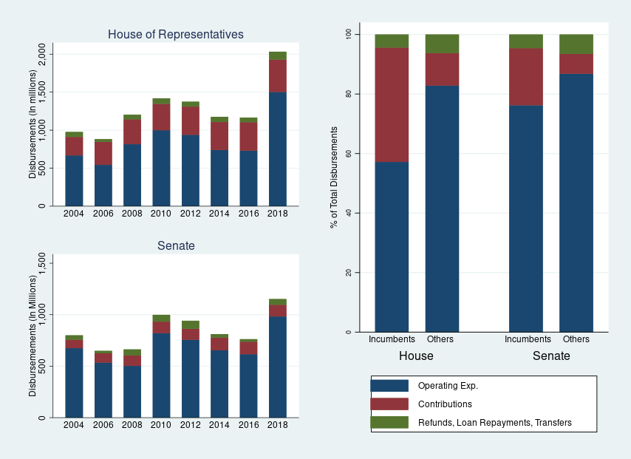
NOTE: Figure shows the aggregate disbursements for House and Senate candidates (Panels A & B) and separately for incumbents and challengers, by type of disbursement. The sample is Congressional elections for 2004-2018. Values are inflated to 2020 dollars.

FIGURE 2: Marginal Spending
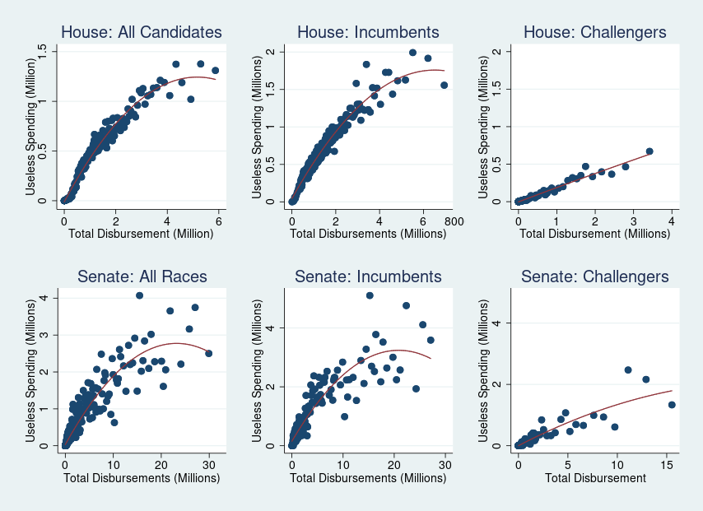
NOTE: Figure shows the relationship between total disbursements and “useless” spending across different groups of candidates. Useless spending includes loan repayments, refunds, transfers, and contributions. Dots reflect the average variable values for observations in 200 bins across the value of total disbursements. The red lines are quadratic best fit lines. The sample is Congressional elections for 2004-2018. Values are inflated to 2020 dollars.

FIGURE 3: Spending and Competition
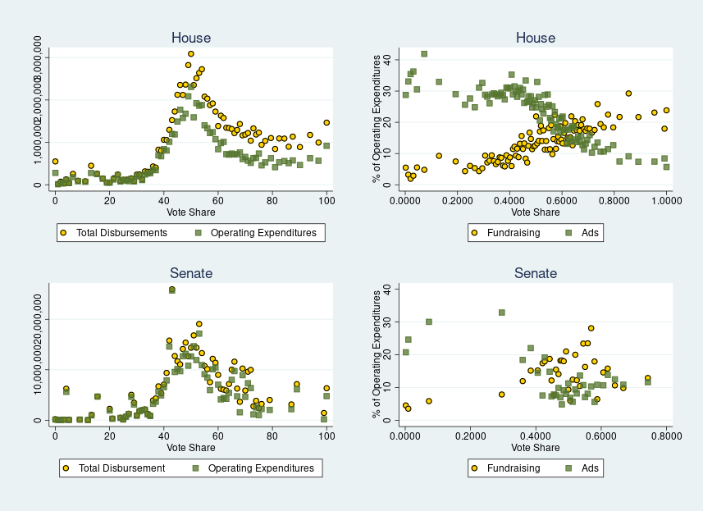
NOTE: Figure shows the relationship between spending patterns and candidate vote shares. Dots reflect the average variable values for observations in bins across the value of candidate vote shares. The sample is Congressional elections for 2004-2018. Values are inflated to 2020 dollars.

FIGURE 4: Within-Candidate Comparison
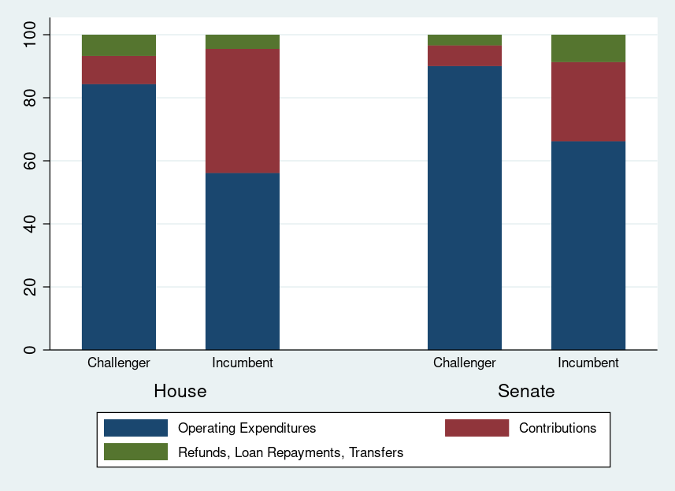
NOTE: Figure shows relative spending patterns for the same candidates before and after they became incumbents. The sample is Congressional elections for 2004-2018. Values are inflated to 2020 dollars.

FIGURE 5: Regression Discontinuity Results
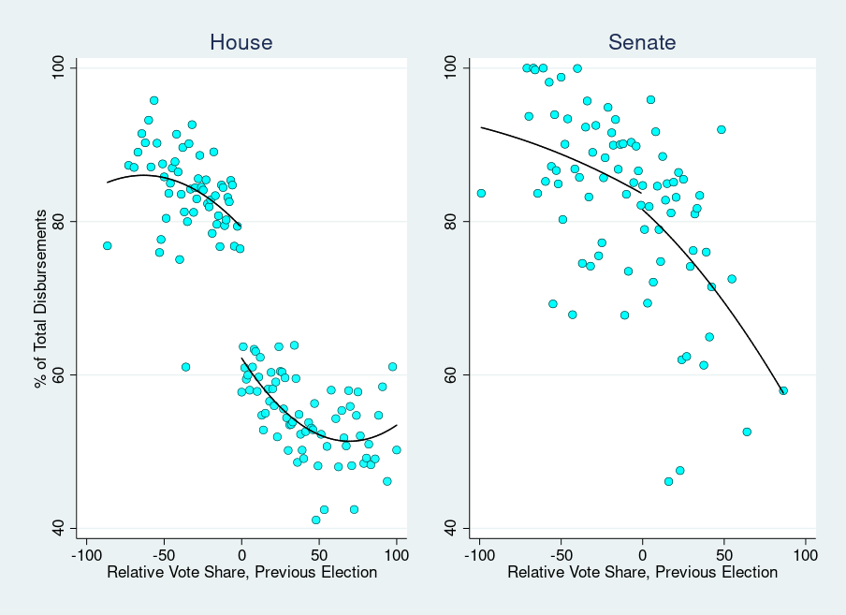
NOTE: Figure shows operating expenditures as a percentage of total disbursements. The x-axis shows a party’s vote share in the previous election relative to the next best candidate. The sample is Congressional elections for 2004-2018. Values are inflated to 2020 dollars.

The ubiquity of the use of disbursements is so significant that in much of the literature, “disbursement”, “expenditures”, and “spending” are all used interchangeably.
I aggregate loan repayment, refunds, and transfers to other authorized committees, given their small individual percentage.
I say “at least” because a percentage of operating expenditures also appear to be contributions, loan repayments, or refunds that are incorrectly labeled operating expenditures. I estimate this to be small, but at least one half of one percent of all operating expenditures fall into this category.
I aggregated challengers with candidates for open seats, as their spending patterns were similar. As such, Panel B is a useful comparison between incumbents and challengers.
In all challenger/incumbent analysis, I restrict my sample to races in which the spending by both the incumbent and challenger has been reported. This eliminates races in which one of the candidates does not file any financial reports with the FEC.
This spike in spending could also lead researchers to underestimate incumbency effects. If incumbency causes a spike in useless spending, regressions that fail to estimate the effect of spending of challengers and incumbents separately will erroneously attribute more effect to increases in incumbent spending than is warranted.

